**CREATE TEXT TO SPEECH SERVICE**

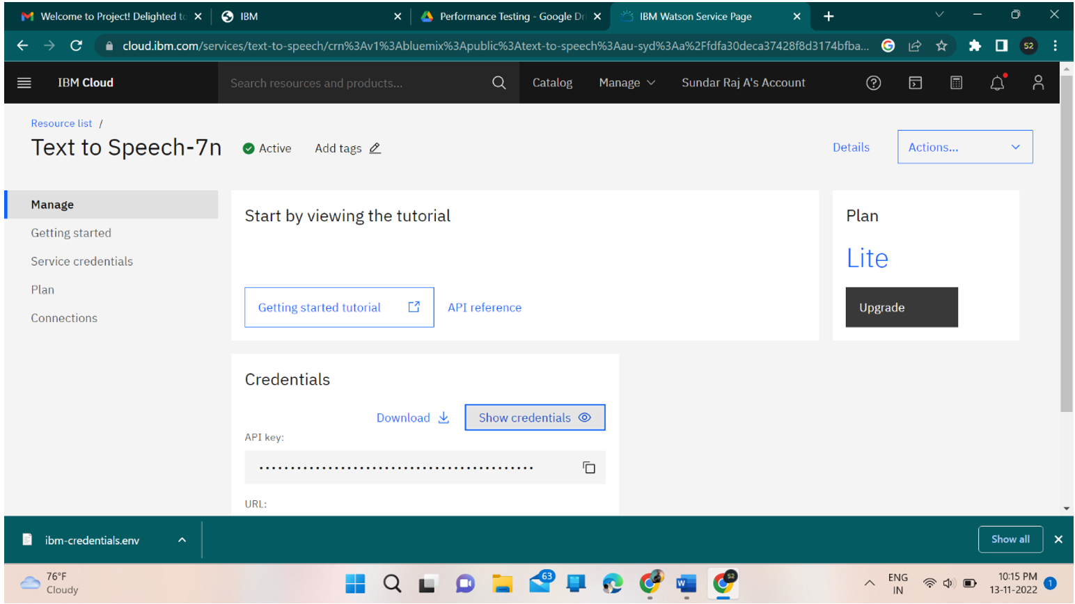

**CREATING TEXT TO SPEECH SERVICE SUCCESSFULLY**